**SOFTWARE DEVELOPMENT LABORATORY**

**EXPERIMENT: 1**

**CREATE THE PRODUCT BACKLOG**

**AIM:**

To create a product backlog using Monday.com that contains all the ideas and work items that might be used into the product over time.

**PROCEDURE:**

1. In the Monday.com website sign up with email and password and create the project with the necessary details.
2. Enter project title and enter the team members who are all going to work under the project.
3. Choose the domain of the project as educational research .
4. Invite the team members to the project by sending the invitation through the email.
5. The workspace will be appeared with the projects needed details.

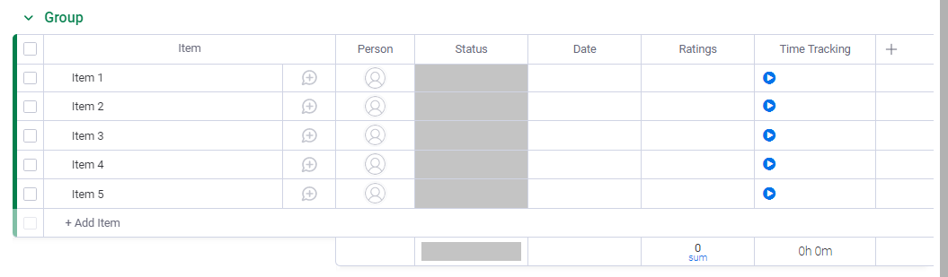

1. The team members can be viewed in the panel.

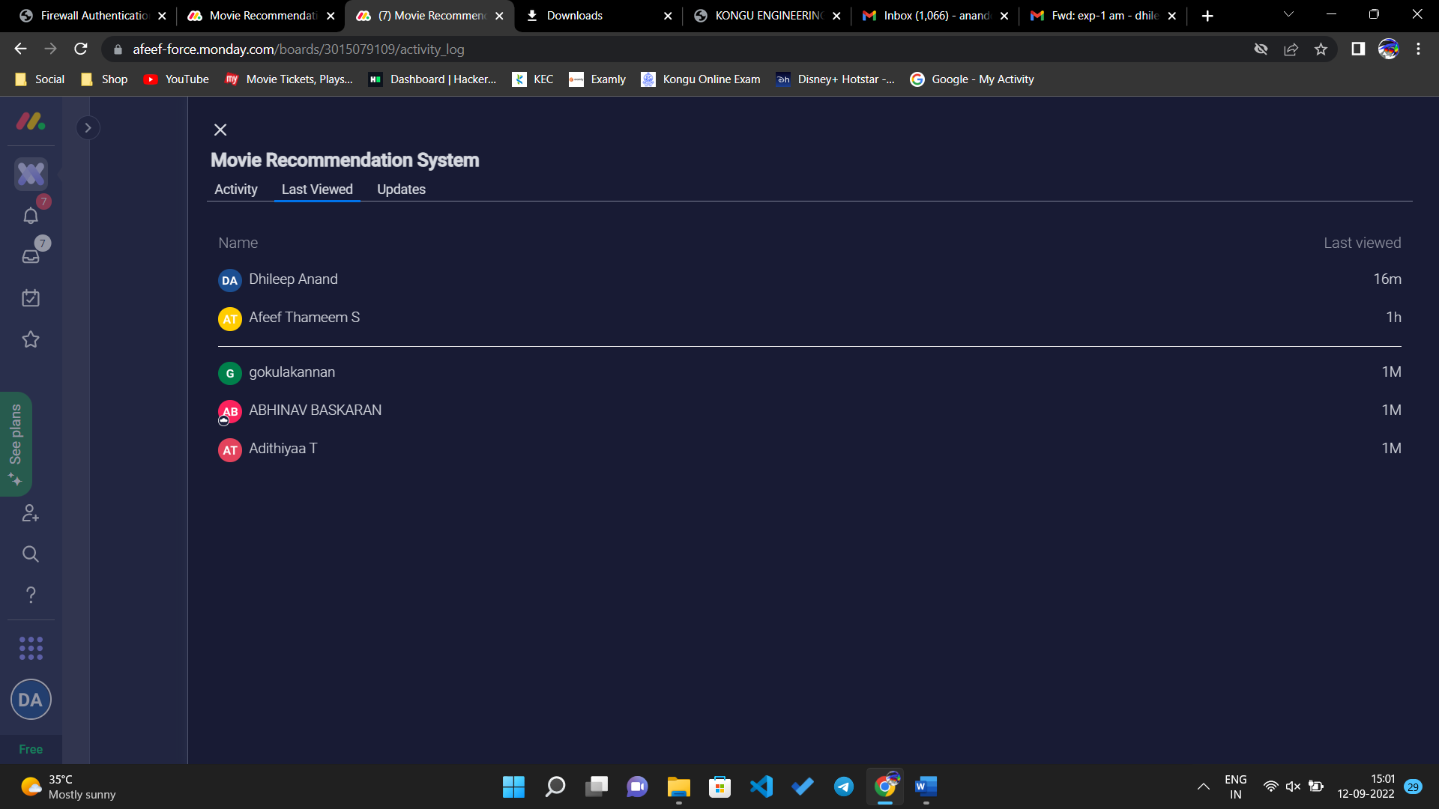

1. The ideas to complete the project can be edited and the persons can be allotted.

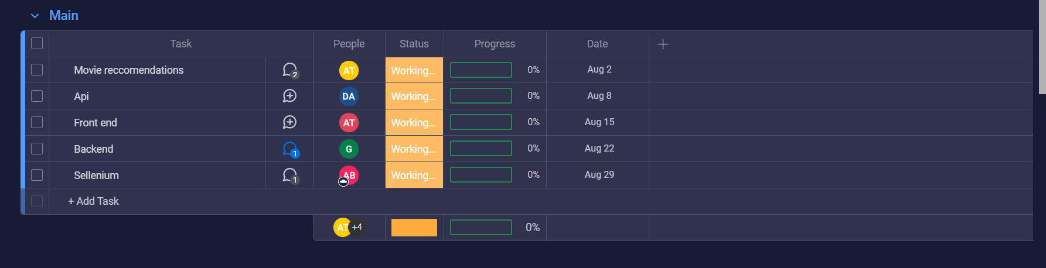

1. Through the activity log all the team members can view each other’s work progress.

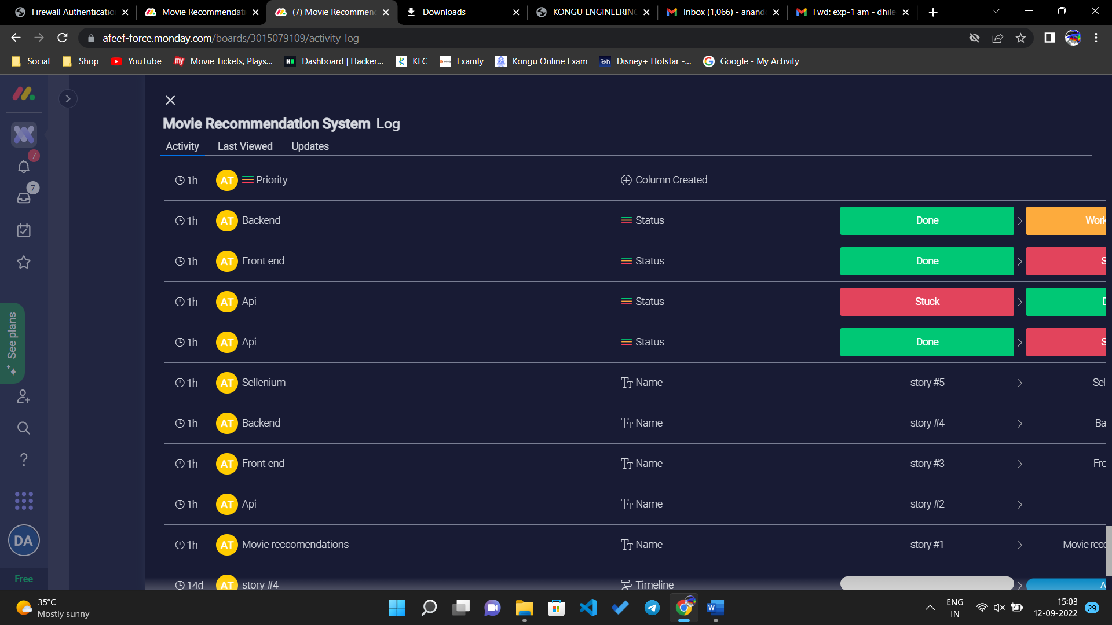

1. The deadlines to finish the work can also be mentioned in the task page.
2. Save all the work and discuss with the team members.

**RESULT:**

Thus, the product backlog can be created with Monday.com and the work ideas are discussed with team members

**SOFTWARE DEVELOPMENT LABORATORY**

**EXPERIMENT 2:**

**PLAN THE RELEASE**

**AIM:**

To plan the release using Monday.com by pulling items from the product backlog into the release. The release can be revised later, and items can be moved back to the product backlog.

**PROCEDURE:**

Evaluate the product vision and roadmap single out outcomes. Focus on outcomes in terms of which are the most important in the short to medium term.

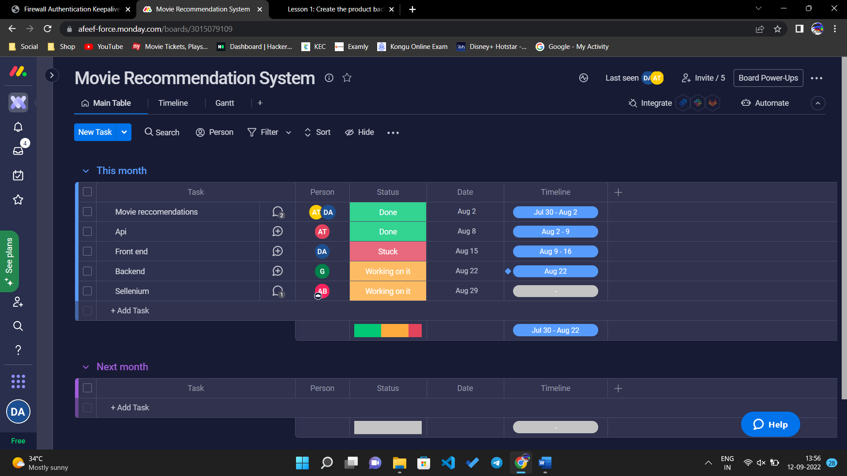

The meet can be conducted with team for a product backlog refinement meeting. Break down desired outcomes into specific user stories and add them to backlog.

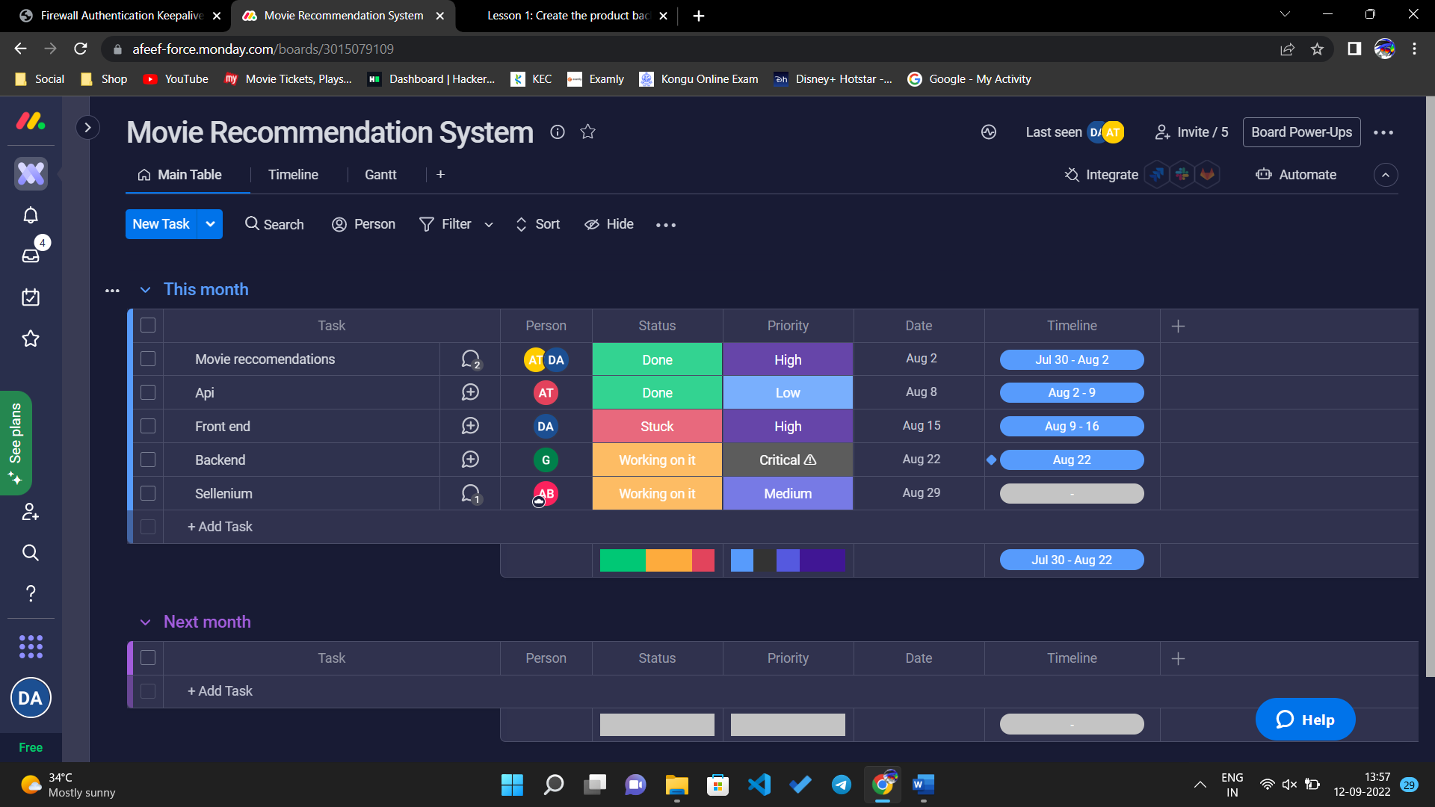

Create a release goal that combines different user stories into a meaningful change in user experience.

Once the release gets done and targeted user stories, it’s time to start planning your actual sprints.

**CONCLUSION:**

Because the release backlog is used to maintain the release work, make sure that it contains only the items that are targeted for the release. Next, the scrum master works with the team to identify which items can be contained in the first sprint.

**SOFTWARE DEVELOPMENT LABORATORY**

**EXPERIMENT 3:**

**PLAN THE SPRINT**

**AIM:**

To create and plan the sprint using Monday.com. The purpose of sprint planning is for the team to commit to complete a collection of stories that add new functionality to the product by the end of the sprint.

**PROCEDURE:**

In the Monday.com website sign up with email and password and create the project with the necessary details.

Open the release backlog by opening the respective project name.



Move work items from the release backlog to sprint. In main, the work items can be drag from release to sprint.

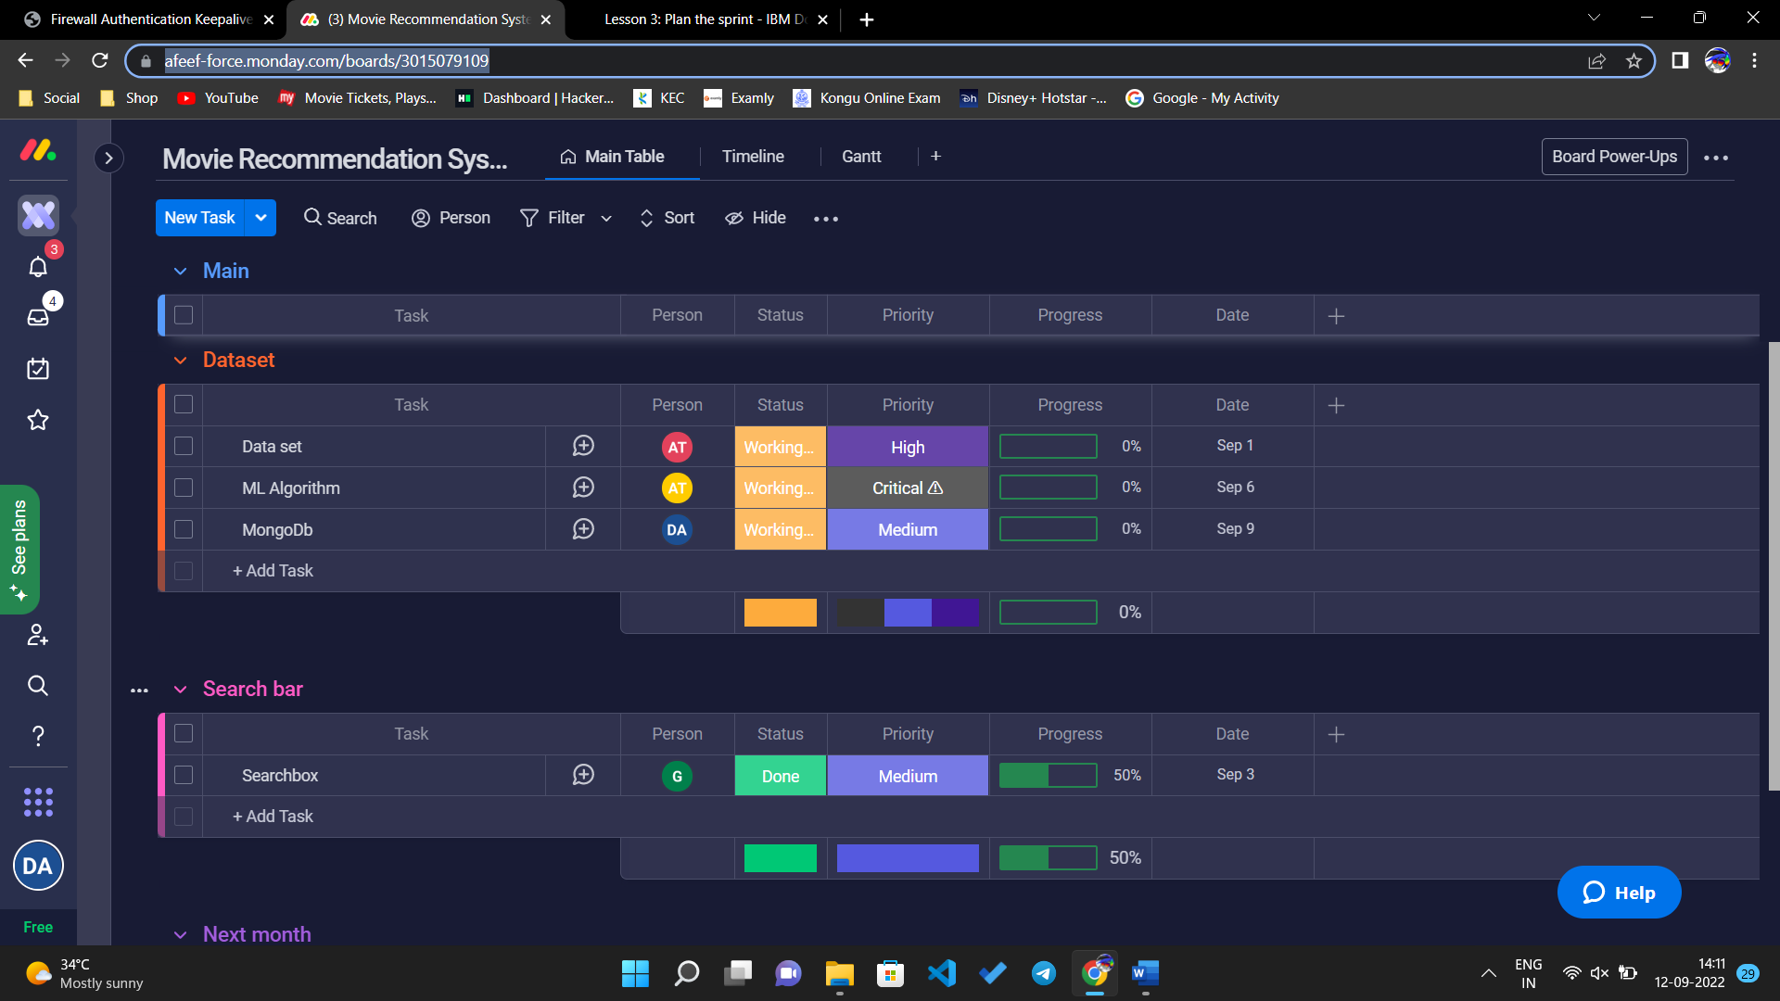

To complete the work for a story, add tasks that break the work into manageable chunks. In a typical sprint planning meeting, the team members mention the tasks to do and the scrum master records the tasks.

Estimate the tasks and assign their owners. The owners can be assigned by changing the person in the sprint.

Click the task to view subitems for a task and the time line for the subitems can also be used.

Continue to add estimates for all of the tasks in the story. After you finish estimating tasks, you can see the total estimates for the story and the entire sprint. Monitor the available time for team members as they accept tasks by using the Planned Time view. In the row of each team member, a progress bar displays the work load report.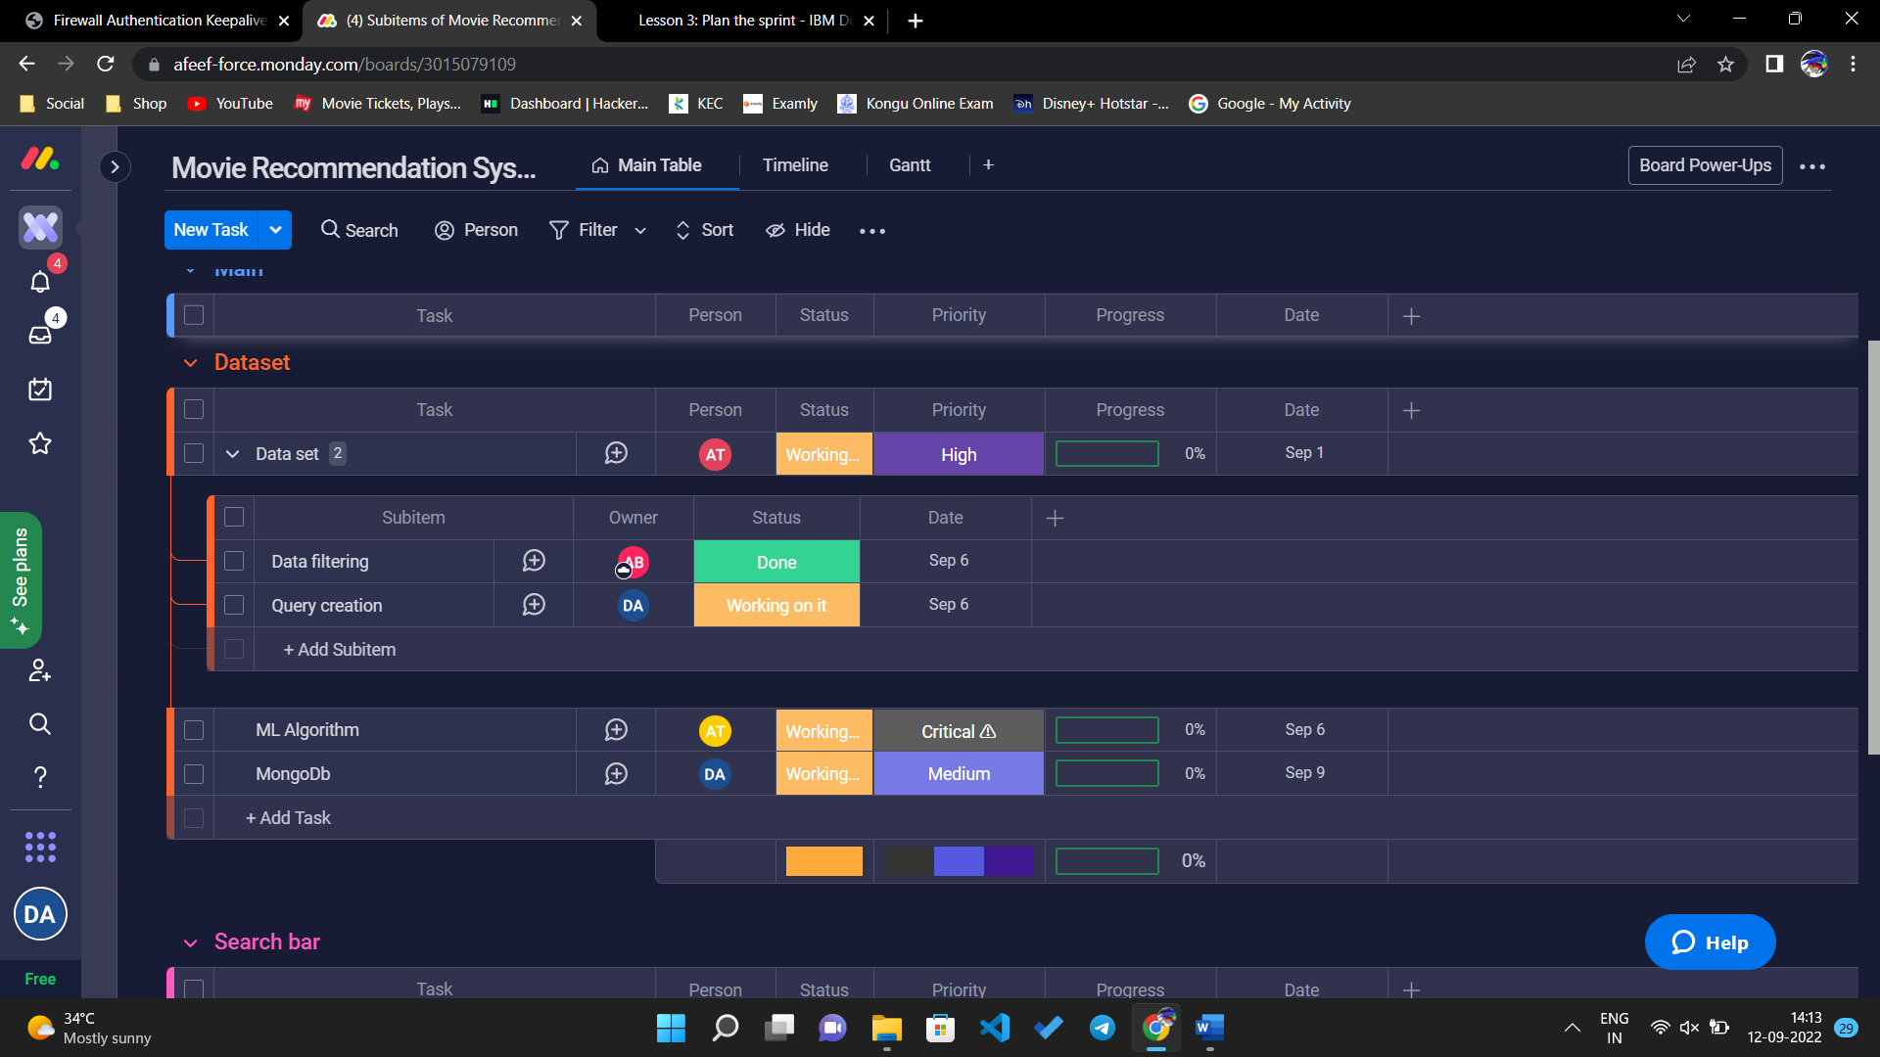

**CONCLUSION:**

Continue to estimate tasks until team members no longer have time available. For scrum teams to succeed, everyone's workload needs spare time to adjust for estimates that are inadequate or interruptions. All of the work that is committed must be completed, no matter what happens. Choose a percentage of spare time that fits your team.

**SOFTWARE DEVELOPMENT LABORATORY**

**EXPERIMENT 4:**

**VIEW YOUR WORK**

**AIM:**

To view the progress of the work team members are going through.  By reporting on and tracking their work, team members ensure that the correct information about the remaining work in a sprint is presented.  Given that the scrum method emphasizes completed work, not started work, start and complete a work item before you move to the next item.

**PROCEDURE:**

In the Monday.com website sign up with email and password and create the project with the necessary details.

Open the release backlog by opening the respective project name.

View your workload in the task board: on the Workspace tab, in the Dataset iteration.

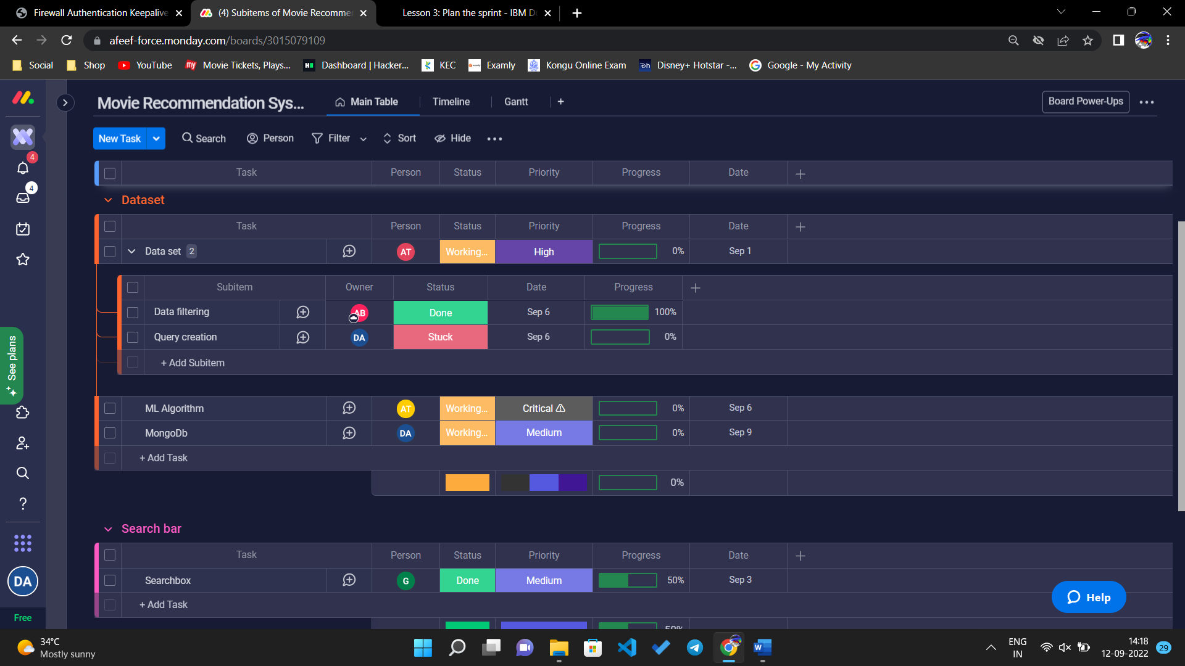

View sprint to make sure the task is on process and needs attention to get that done. Update the work progress of the particular task every time the things get done.

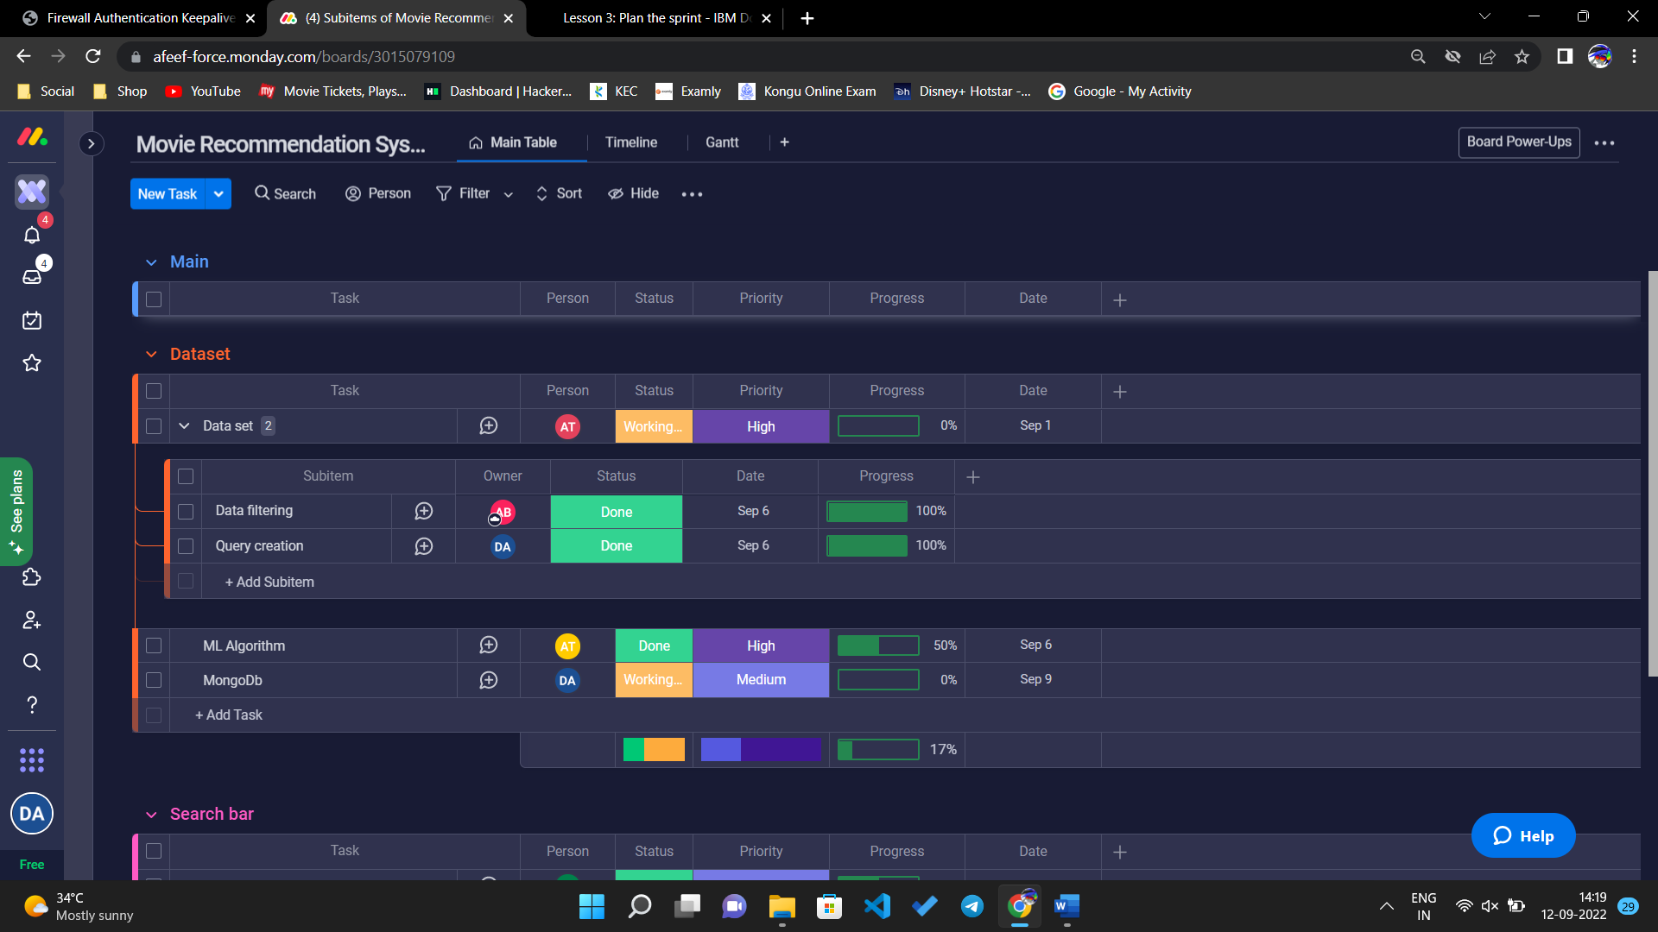

The task assigned for each team members can be viewed by selecting particular person in the taskbar.

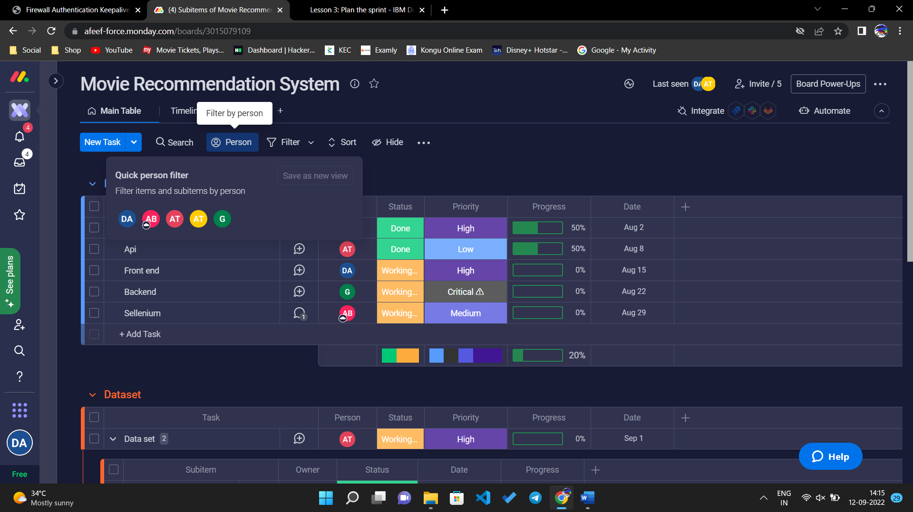

Click the tab person and select the particular person whom work progress need to be known.

The work of that particular person can be viewed.

Each team members progress can be check by this.



**CONCLUSION:**

Any team member can update information in the discussion section, which provides an excellent way to capture the history of the work item and use a collaborative approach.

**SOFTWARE DEVELOPMENT LABORATORY**

**EXPERIMENT 5:**

**TRACK PROGRESS USING QUERIES**

**AIM:**

To track progress of work of each team member using queries using Monday.com. Queries provide a flexible way to track work. You can use several predefined queries, and you can create your own queries.

**PROCEDURE:**

In the Monday.com website sign up with email and password and create the project with the necessary details.

Open the release log by entering the project name and review the progress of the work in release log and in the sprint.

The activity log for the particular task can be viewed by clicking the task and then open.

Then click activity log in the right panel.

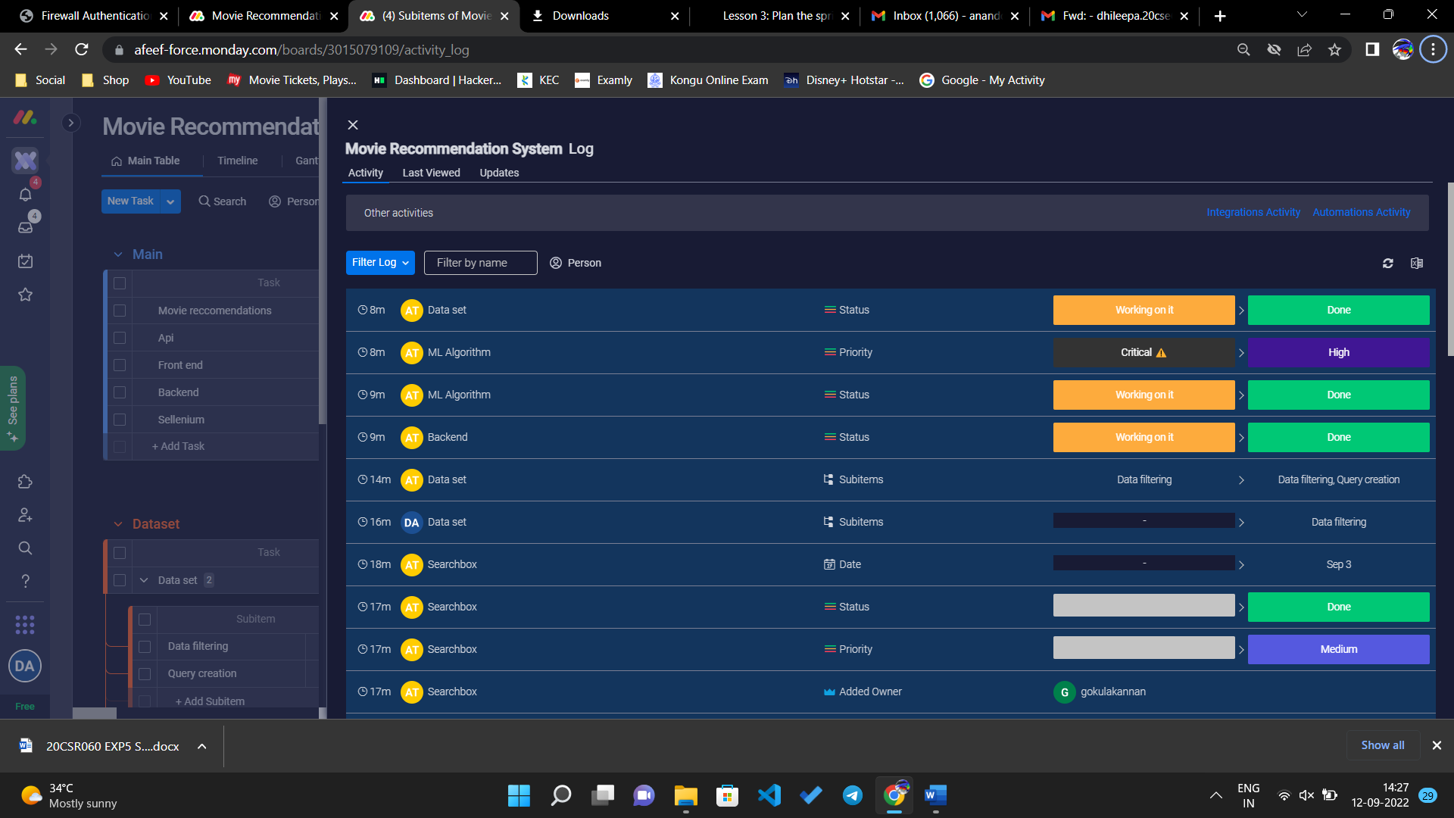

The progress can be updated or doubts can be clearing by queries by clicking chat icon in right side of task.

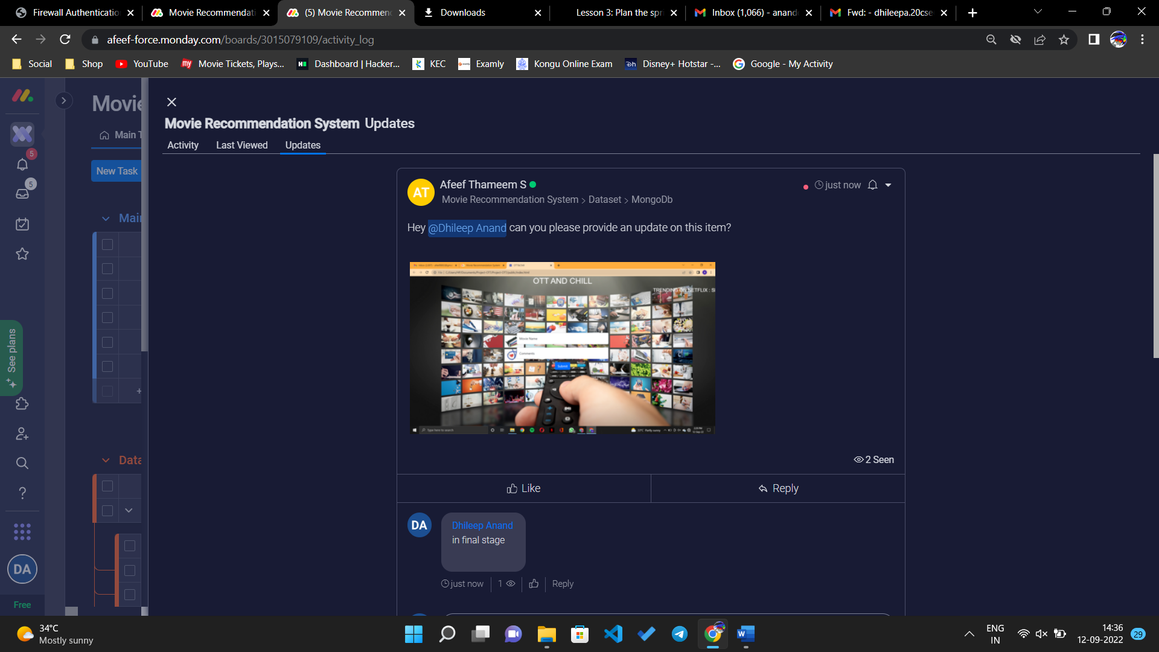

The conversation can be done by mentioning the team members also using symbol @.

The conversation can be start by clicking write an update and the queries can be updated.

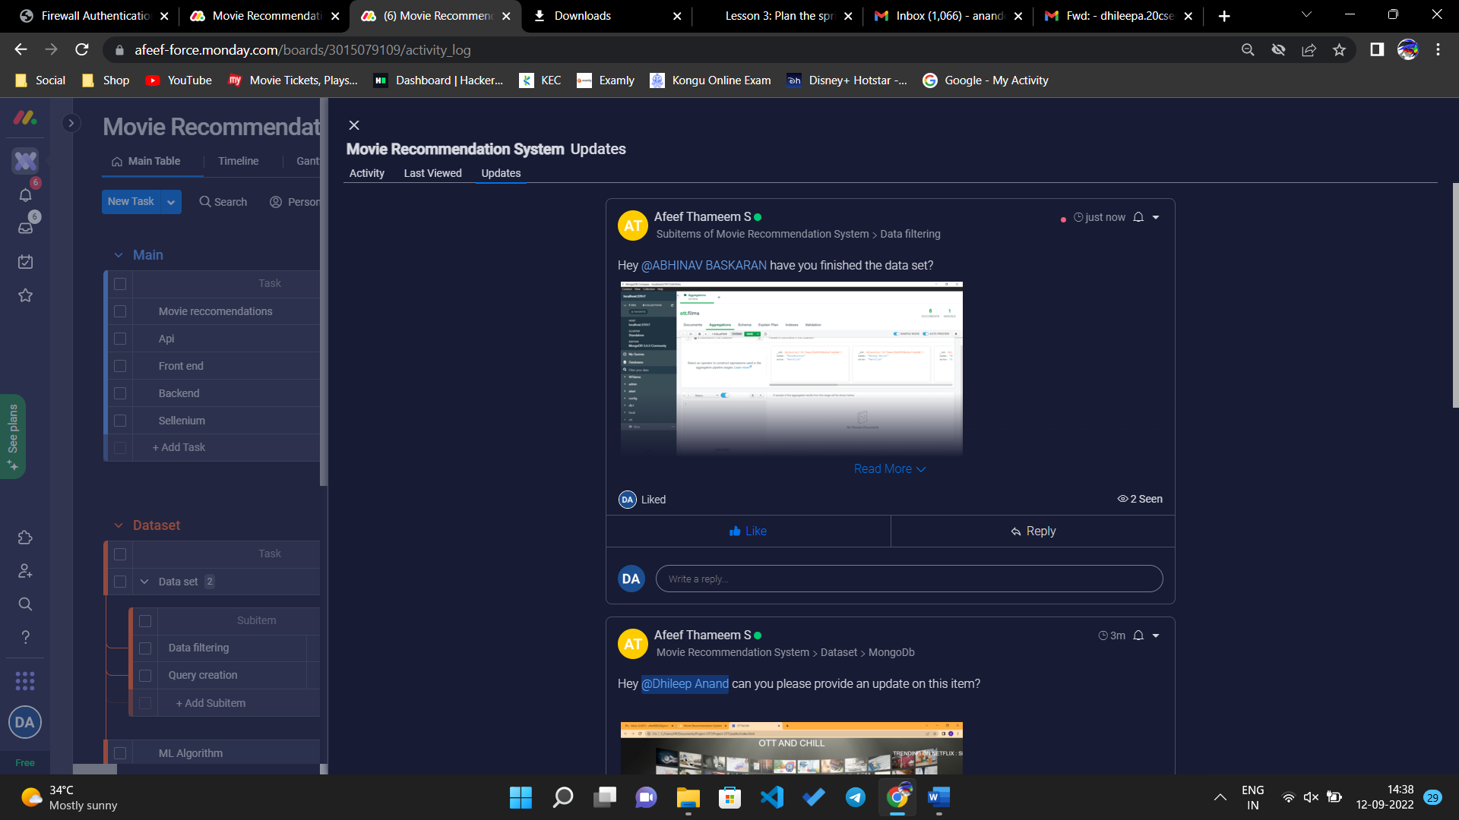

The files, emoji can also be updated. Then click update to send query to team members.

**CONCLUSION:**

Thus, the queries can be asked and the work progress can be updated with the team members.

**SOFTWARE DEVELOPMENT LABORATORY**

**EXPERIMENT 6:**

**SCHEDULE THE SPRINT REVIEW**

**AIM:**

To schedule the sprint for the review after done the task. An important part of the scrum process is the sprint review meeting. The first part of this process is showing demos to the stakeholders. The second part of the process is the retrospective, which is sometimes called the reflection.

**PROCEDURE:**

In the Monday.com website sign up with email and password and create the project with the necessary details.

Open the release log by entering the project name and review the progress of the work in release log and in the sprint.

After the demos are shown to stakeholders, add feedback and comments about the review to the sprint plan

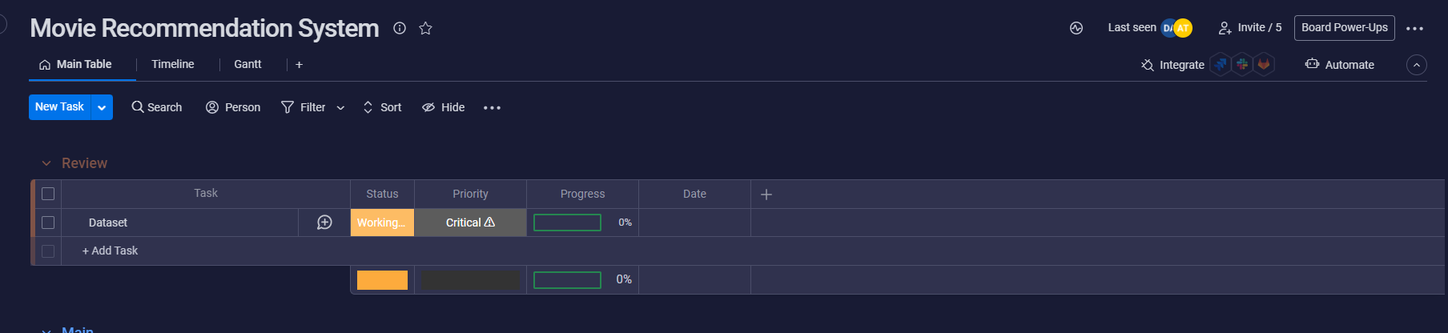

The task can be drawn from sprint to the review and the date can be fixed to review the sprint after all things is done by the team members.

Then the sprint can be processed and the sprint can be reviewed and the satisfactory reviews can be updated by sending the update message for the task.

The next part of the sprint review meeting is the retrospective, or reflection. The team discusses what went well, what did not go well, and what they plan to do.

To schedule the reflection meeting and track the team's comments and plans, use the Retrospective work item type, which is part of the Scrum process template.

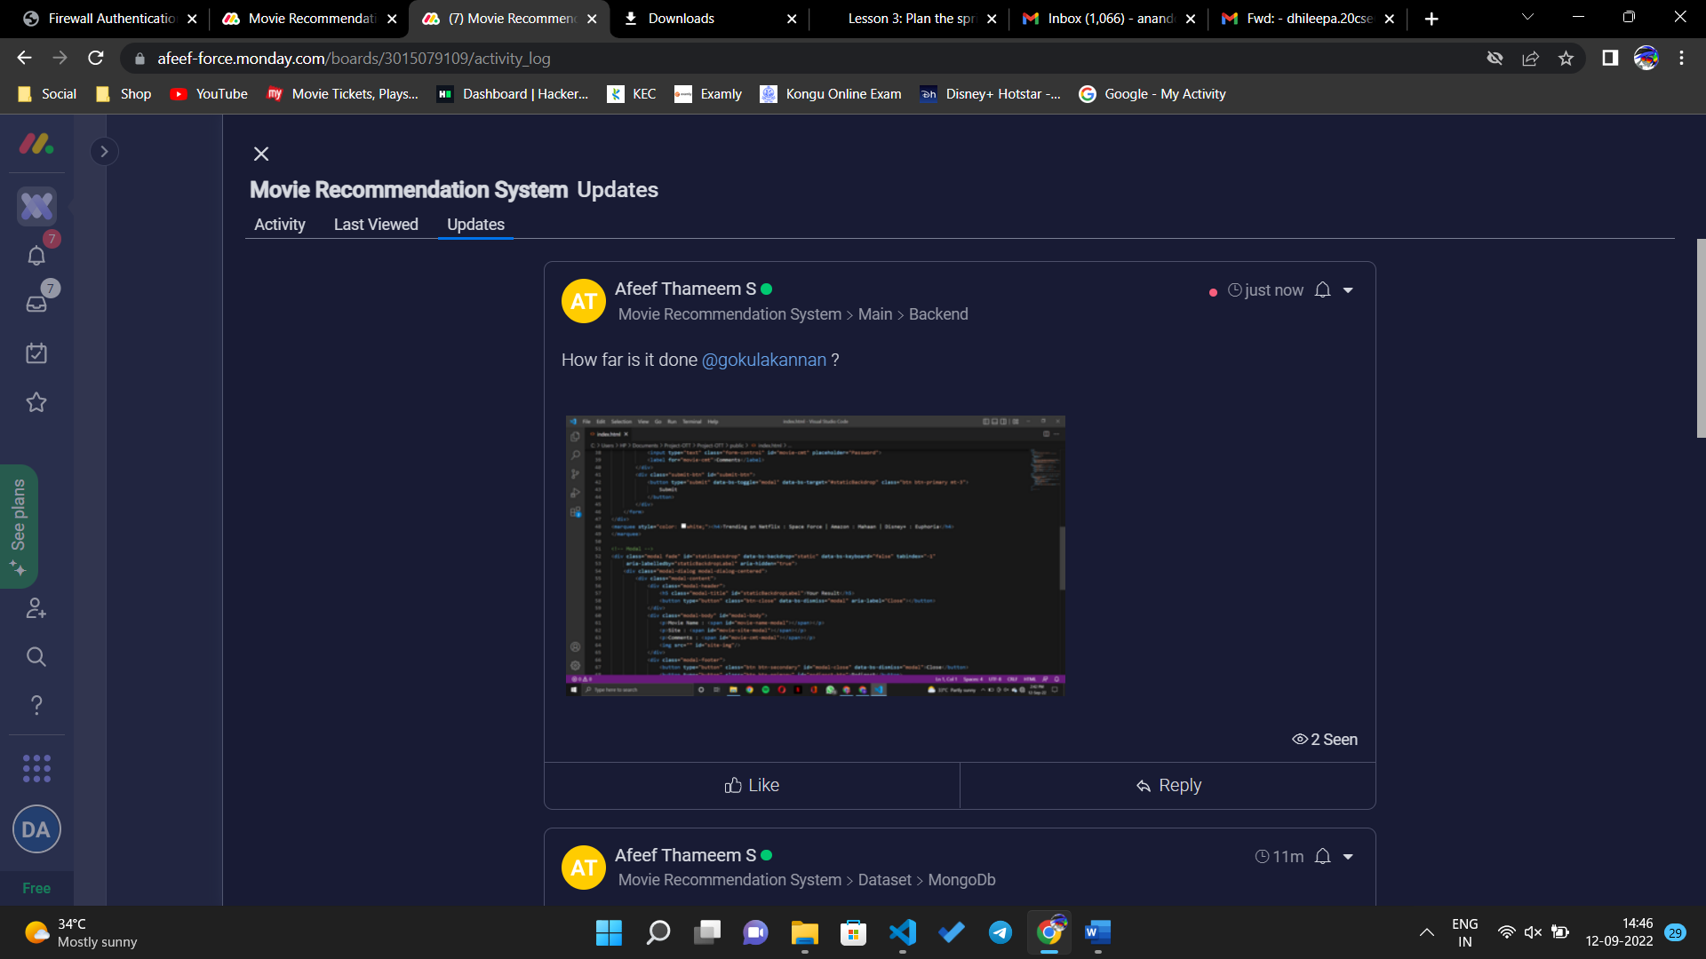

**CONCLUSION:**

Team members can add thoughts to the Discussion section, and the team can review the discussion at the meeting.